**Project Design Phase-II**

**Technology Architecture**

|  |  |
| --- | --- |
| **Date** | **07 November 2022** |
| **Team ID** | **PNT2022TMID10019** |
| **Project Name** | **Analytics for Hospital’s Health-Care Data** |
| **Maximum Marks** | **4 Marks** |

**Technical Architecture:**

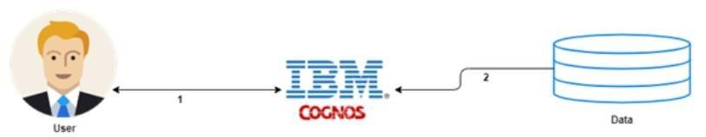

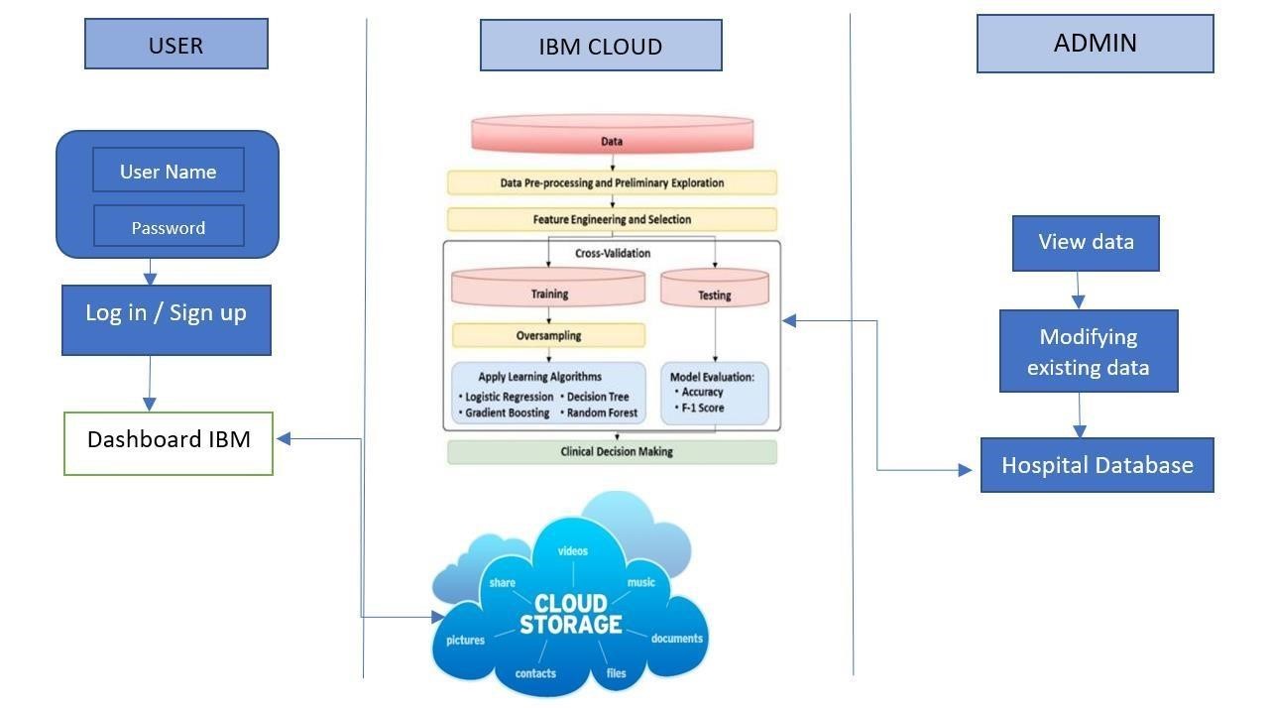

**Table-1 : Components & Technologies:**

|  |  |  |  |
| --- | --- | --- | --- |
| **S.No** | **Component** | **Description** | **Technology** |
| 1. | User Interface | How user interacts with application e.g. Web UI, Mobile App, Chatbot etc. | HTML, CSS, JavaScript / Angular Js  / React Js etc… |
| 2. | Application Logic-1 | Logging in as a patient / user in the application | Python |
| 3. | Application Logic-2 | Logging in as an admin in the application | IBM Watson Assistant |
| 5. | Database | All the data about patients such as disease, address and etc.. | MySQL, NoSQL, etc. |
| 6. | Cloud Database | IBM Watson cloud is used for storage, Cloud | IBM DB2, IBM Cloudant etc. |
| 7. | External API-1 | Purpose of External API used in the application | Aadhar API, etc.. |
| 8. | Machine Learning Model | Purpose of Machine Learning Model | Regression Model, etc. |
| 9. | Infrastructure (Server / Cloud) | Application Deployment on Local System /  Cloud  Local Server Configuration,  Cloud Server Configuration | Local, Cloud Foundry, Kubernetes, etc. |

**Table-2: Application Characteristics:**

|  |  |  |  |
| --- | --- | --- | --- |
| **S.No** | **Characteristics** | **Description** | **Technology** |
| 1. | Open-Source Frameworks | List the open-source frameworks used | Python |
| 2. | Security Implementations | List all the security / access controls implemented, use of firewalls etc. | Encryption. |
| 3. | Scalable Architecture | Justify the scalability of architecture (3 – tier, Micro-services) | Can supports higher workloads |
| 4. | Availability | Justify the availability of application (e.g. use of load balancers, distributed servers etc.) | Highly available |
| 5. | Performance | Design consideration for the performance of the application (number of requests per sec, use of Cache, use of CDN’s) etc. | It performs good uses various tools and ideas in a scientific manner to meet the desired outcomes |